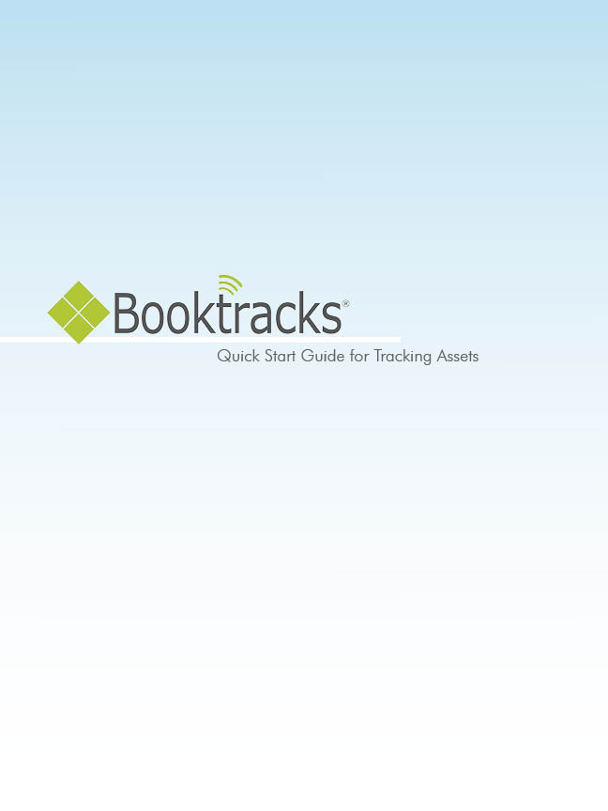
Note to the Administrator: This guide includes key tasks that may need to be preformed by different personnel. Book Systems, Inc. is providing this document to you in Word allowing you to make changes specific to your school’s policies and procedures.

Table of Contents

Add Equipment Records 3
Adding Holdings to Existing Equipment Record 4
Printing Item Barcodes 8
Print Patron Barcodes 10
Check Out Items 12
Check In Items 14
Self Check Out 18
Self Check In 22
Reclassify Items 24
Last Checked Out To Report – Accession List 26
Equipment Summary 29
Equipment Expense Report 31

Disclaimer! You can customize steps in the Word file as needed; Book Systems is not responsible for any errors contained in Word files that have been altered after delivery.

Add Equipment Records

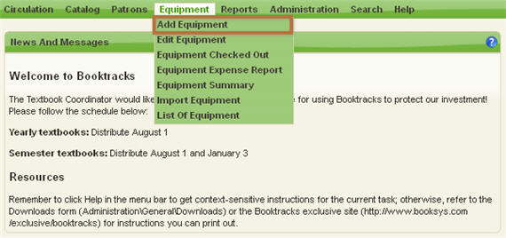
- Click Equipment\Add Equipment from Booktracks’ Menu Bar.
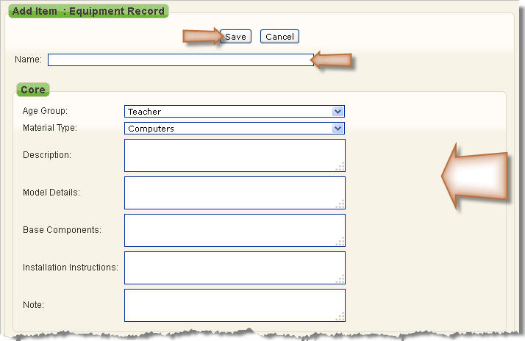
- Enter the name of the equipment, a description, model details, base components, etc. in the corresponding fields as needed.
- Select the appropriate Age Group and Material Type from the drop-down lists.
- Click Save.
- Use the steps in the next section to add holdings; if you add holdings immediately, you can skip to step 5 in the Adding Holdings to Existing Equipment Record instructions.

Adding Holdings to Existing Equipment Record

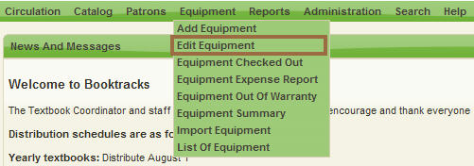
- Click Equipment\Edit Equipment from Booktracks’ Menu Bar.
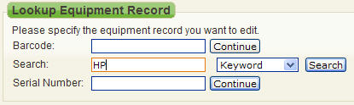
- Enter the exact name of the equipment or a keyword in the Search: field.
- Click Search.
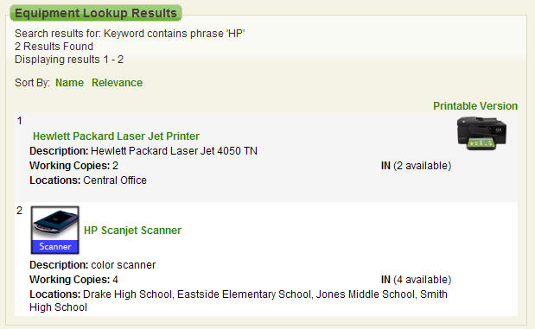
- If you see Equipment Lookup Results, click the name of the equipment you need.
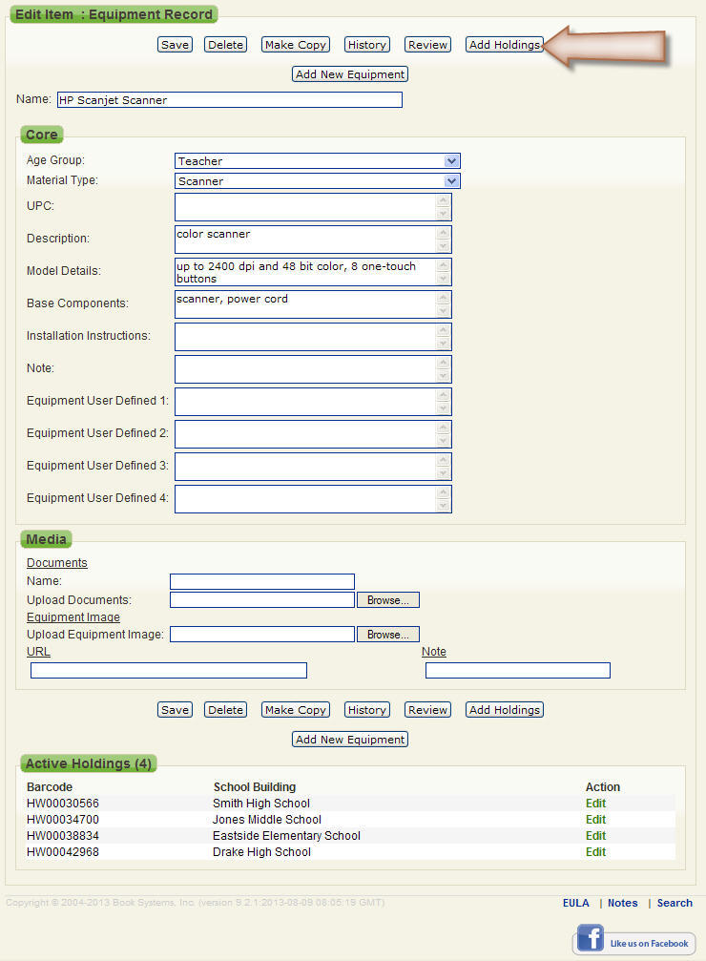
- When the Edit Item: Equipment Record form opens, click Add Holdings.
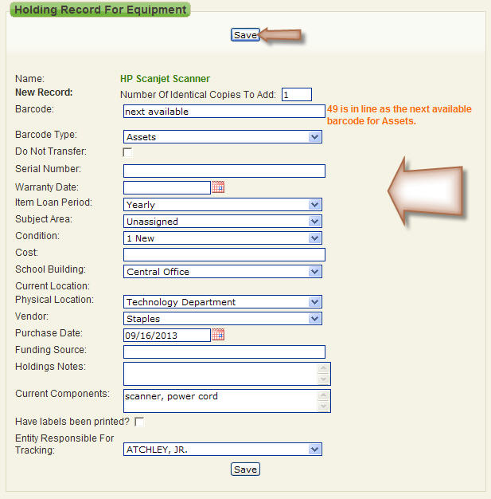
- If you want to assign your own barcodes (for example, serial numbers), scan or enter the number in the Barcode: field; otherwise, accept the “next available” barcode.
- In the New Record: Number Of Identical Copies To Add: field, leave the default “1.”
- Enter the unique serial number of the asset in the corresponding field.
- Click the calendar icon next to Warranty Date:, and click again to select a day.
- Select the correct loan period from the Item Loan Period: drop-down list.
- Enter the price of the asset in the Cost: field.
- Select your school from the School Building: drop-down list.
- If needed, select the correct entity (teacher) from the Entity Responsible For Tracking: drop-down list.
- Click Save. A success message displays.
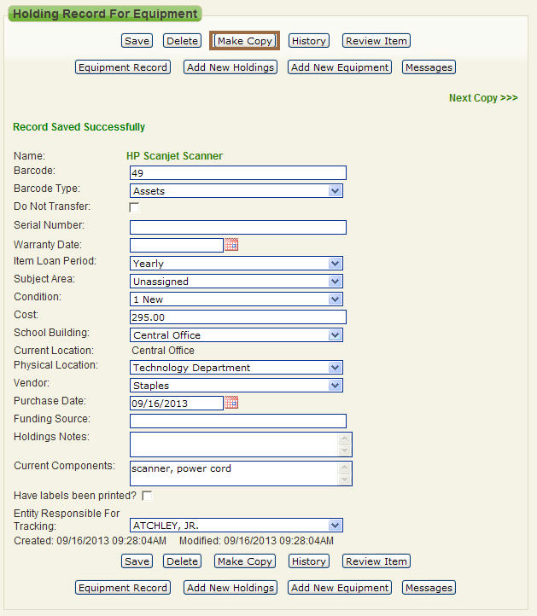
- Click Make Copy to open a duplicate record.
- Make changes to the barcode, serial number, and any other field that needs to be changed.
- Click Save.

Printing Item Barcodes

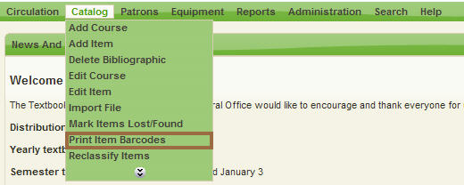
- Click Catalog\Print Item Barcodes from Booktracks’ Menu Bar.
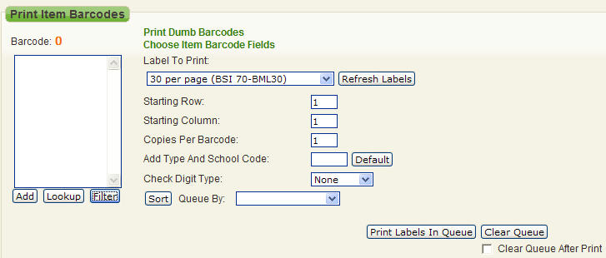
- Click Filter.
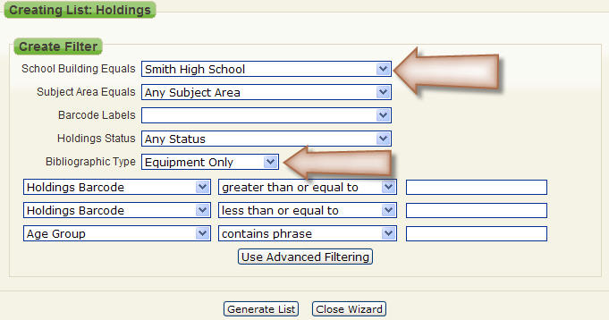
- Select your school from the School Building Equals drop-down list.
- Select Equipment Only from the Bibliographic Type drop-down list.
- Click Generate List.
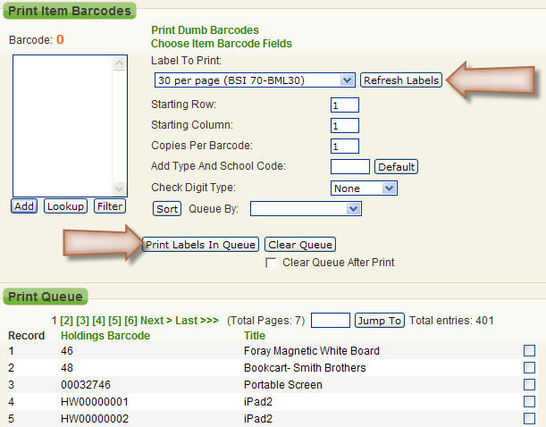
- For Label To Print:, select the choice that matches your label pages. If you need to purchase equipment labels, contact Book Systems.
- Click Print Labels In Queue.
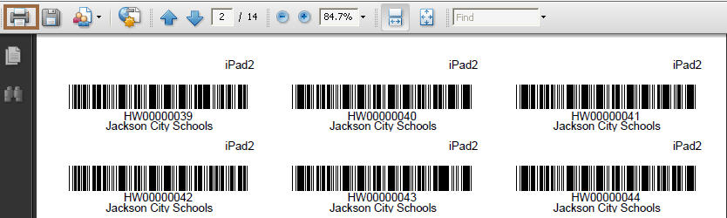
- Click the Print icon.
- Select your printer at the top, and then click OK.
- Place label consistently on the top of the computer.

Print Patron Barcodes

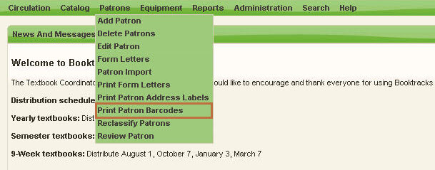
  - Click Patron\Print Patron Barcodes from Booktracks’ Menu Bar.
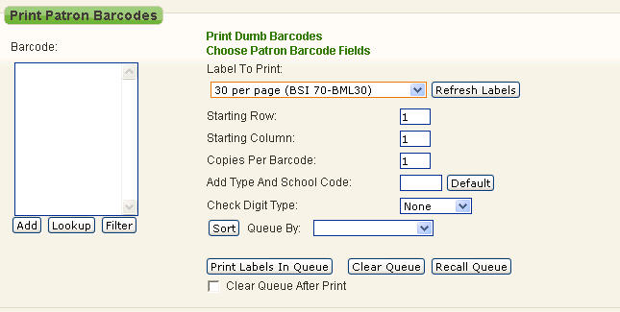
  - Click Filter.
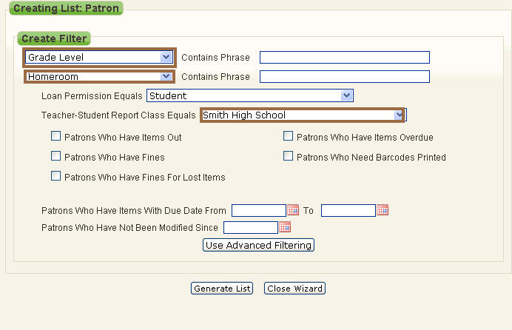
  - Use the drop-down lists at the top to select criteria, such as Grade Level, Homeroom, etc. according to the data in your student records. Then enter your search term in the corresponding field, such as Grade 10, Ms. Smith, etc.
  - Select a choice from the Teacher-Student Report Class Equals drop-down list.
  - Click Generate List.
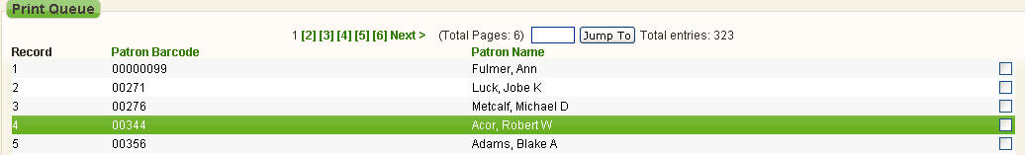
  - For Label To Print:, select the choice that matches your label pages. If you need to purchase equipment labels, contact Book Systems.
  - Click Print Labels In Queue.
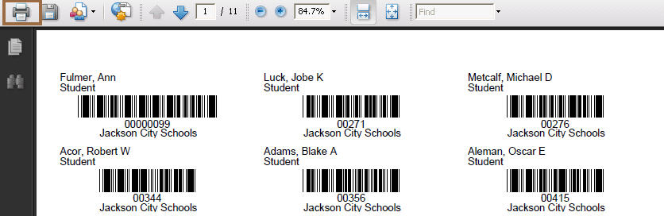
  - Click the Print icon.
  - Select your printer at the top, and then click OK.

Check Out Items

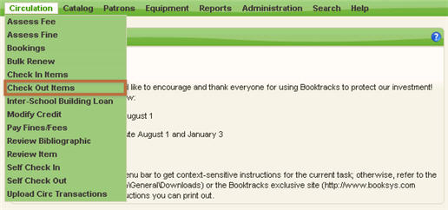

- Click Circulation\Check Out Items from Booktracks’ Menu Bar.

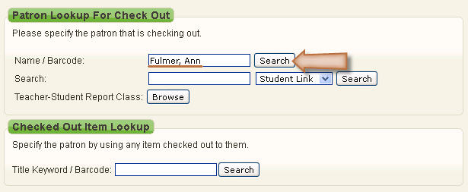
- Enter the student’s or teacher’s name in the Name / Barcode: field, and click Search.
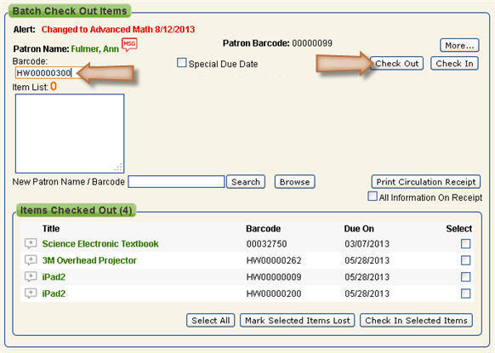
- Scan or enter item barcodes in the Barcode: field. If entering barcodes manually, press Enter between each barcode.
- Click Check Out. Items display on the Check Out Results form.
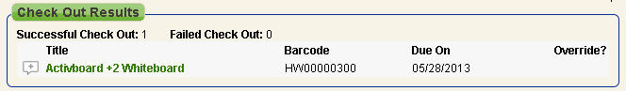

Check In Items

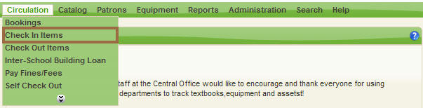
- Click Circulation\Check In Items from Booktracks’ Menu Bar.
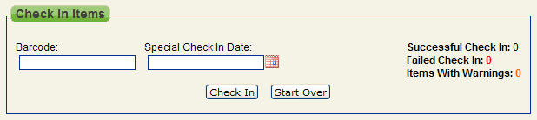
- Scan or enter the item barcode in the Barcode: field.
- If entering barcodes manually, click Check In.
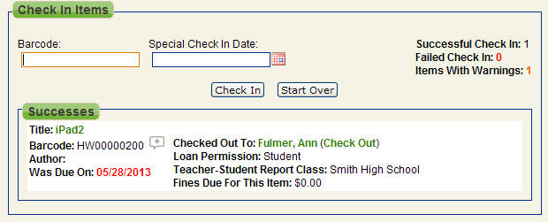
Patron and Item Messages

There are several ways that you can add or view messages on patron or item records. On related forms, you see a gray icon if there are no messages yet or a red icon if messages have already been added.

You can add/view messages during circulation transactions; one example is below.
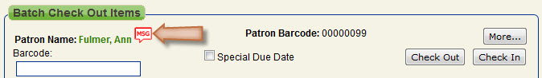
- Click Circulation\Check Out Items, look up the patron, and then click the messages icon next to the student’s name.
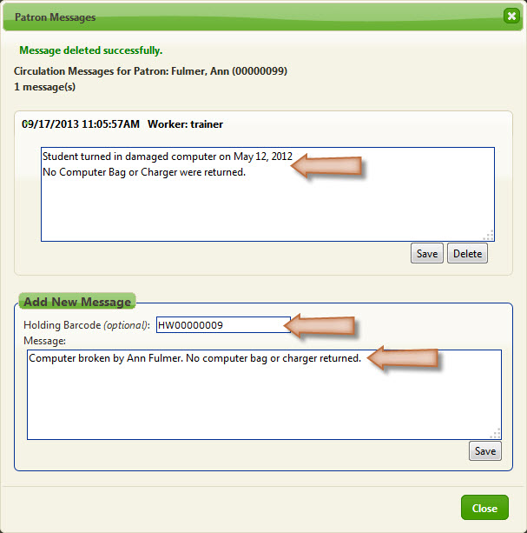
- If you want the message to display on the item record as well as the patron record, you can enter a holding barcode in the corresponding field.
- Enter your message text.
- Click Save.
- Click Close.
You can add/view message from the Holding Record For Equipment form.
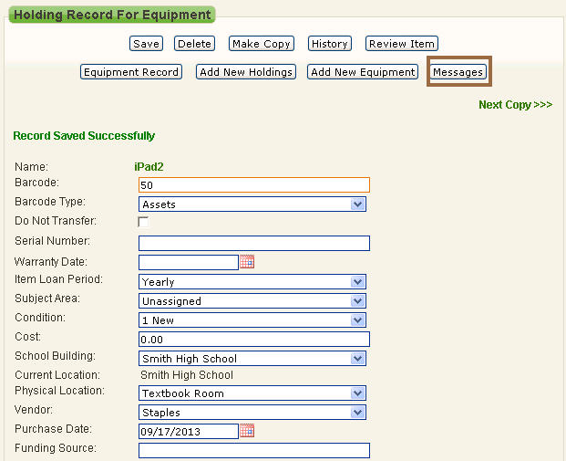
  - Click Equipment\Edit Equipment, search for the main equipment record, click Edit next to a specific holding record, and then click the Messages button.
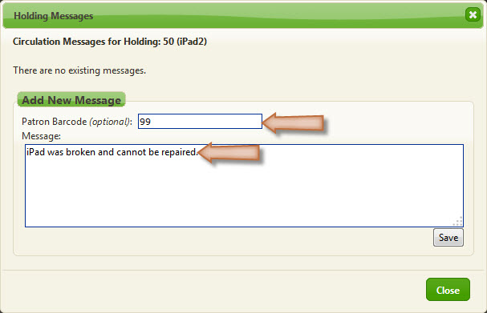
  - You can enter the patron barcode for the person who had the item checked out.
  - Enter the text of your message.
  - Click Save.
  - Click Close.
You can also add/view item messages from the Review Item form.
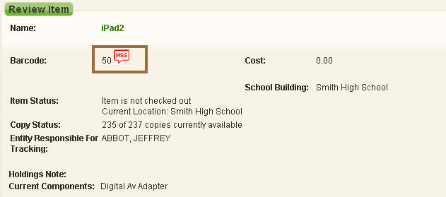
  - Enter a barcode in the Review Equipment Item: field under Equipment Lookup in the Left Column. Then click the messages icon next to the barcode.

You can generate a list of all messages added in your database.
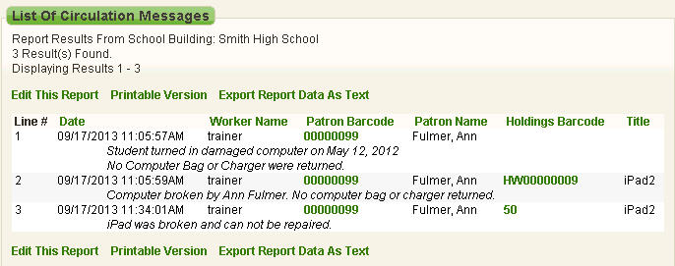
  - Click Reports\Other Reports from Booktracks’ Menu Bar.
  - Click List Of Circulation Messages to open the report in a new window.
  - Click Printable Version to generate a plain text version.
  - Use your browser’s onscreen options to print.

Click Help from Booktracks’ Menu Bar to open a topic related to where you are in the product; if needed, search for “messages” to find a topic with more details about where you can add/view messages.

Self Check Out

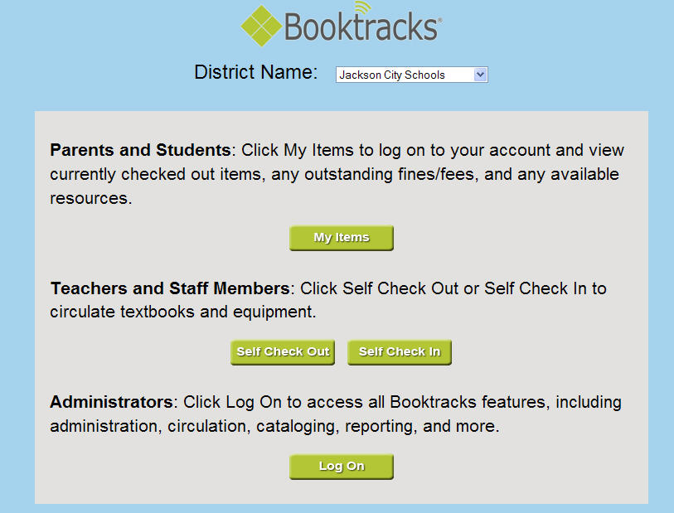
- Enter your Booktracks URL in your browser’s address bar, and press Enter to open the main page.
- Click the Self Check Out button to open the Log On form.
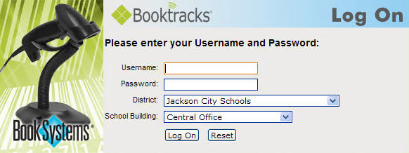
- Enter selfcheckout in the Username: field.
- Enter the password provided in the Password: field.
- Select your school from the School Building: drop-down list.
- Click Log On. Because the circulation setting for choosing entity has been enabled, a screen displays with a button for each Entity Responsible For Tracking.
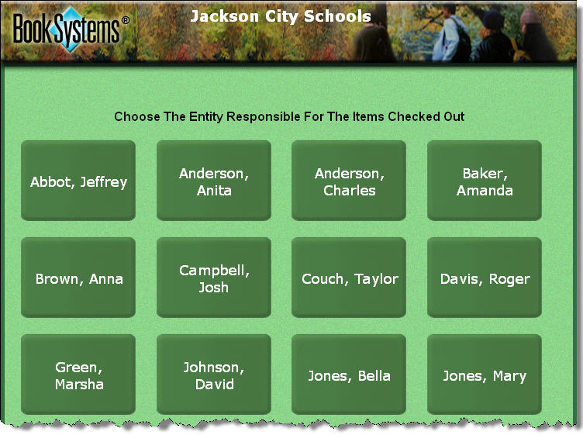
- Click the button with the correct entity (teacher) name.
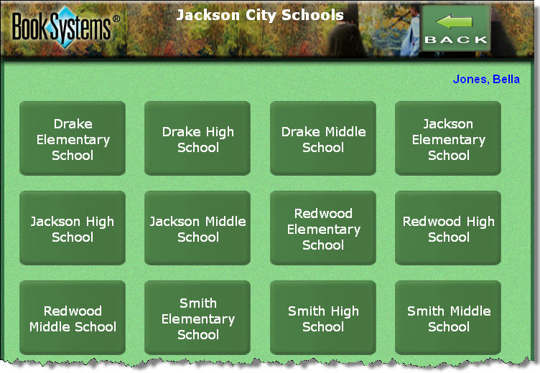
- Because the Self Check Station Settings (circulation settings) lookup method has been set to Choose By Class, the Teacher-Student Report Classes display. Click the button with the correct report class (school name).
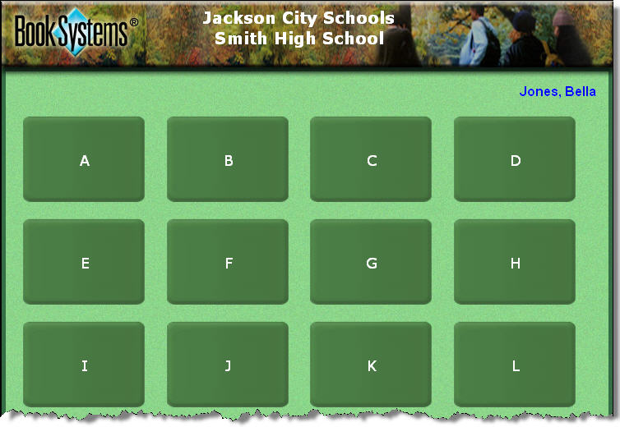
- Click the letter that begins the student’s or teacher’s last name to open a list.
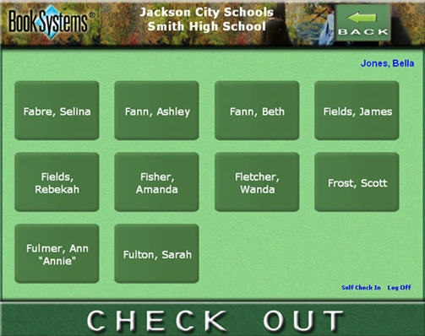
- Click the button with the correct name.
- Scan or enter the item barcode into the Barcode: field. Repeat for each item.
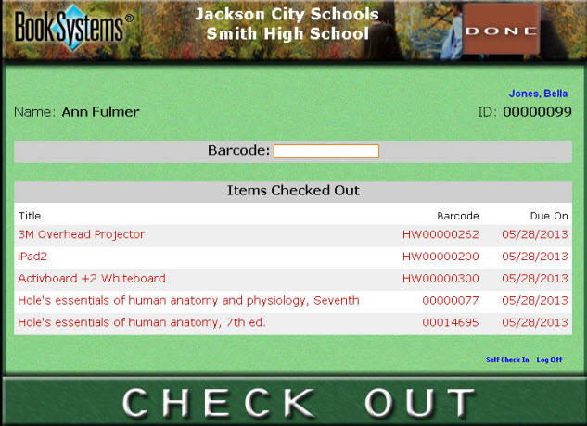
- If you see any errors, record the student/teacher and item information on the Booktracks Check Out Exceptions Log (provided by trainer).
- Click DONE to return to the A to Z button list; the screen reopens automatically after inactivity.
- Repeat steps 9-13 for each new check out transaction.

Self Check In

- Enter your Booktracks URL in your browser’s address bar, and press Enter to open the main page.
- Click the Self Check In button to open the Log On form.
- Enter selfcheckin in the Username: field.
- Enter the password provided in the Password: field.
- Select your school from the School Building: drop-down list.
- Click Log On. Because the circulation setting for choosing entity has been enabled, a screen displays a button for each Entity Responsible For Tracking.
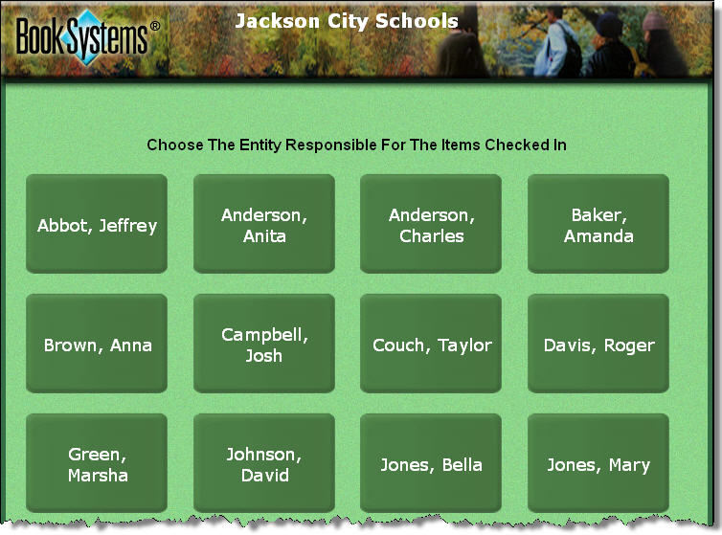
- Click the button with the correct entity (teacher) name.

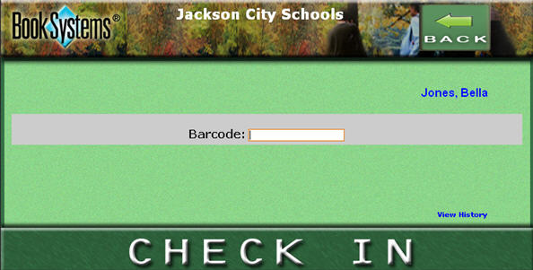

- Scan or enter the item barcode into the Barcode: field. Repeat for each item.

Did you know? You may use Self Check In simply to change the entity in item records even if they are not currently checked out. If this is the case, when you scan the item, an error states that it cannot be checked in (because it was not checked out), and a message lets you know that the entity was successfully changed.

Reclassify Items

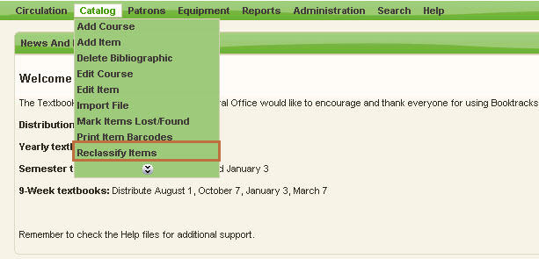
  - Click Catalog\Reclassify Items from Booktracks’ Menu Bar.
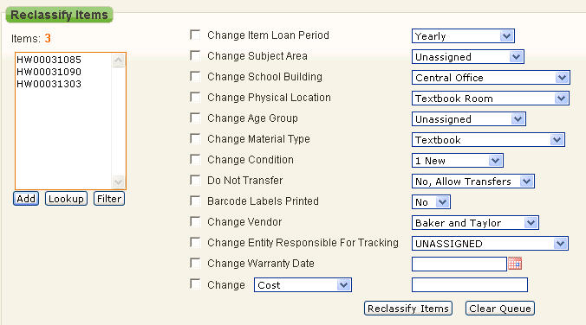
  - Scan or enter item barcodes into the Items: # list and click Add.

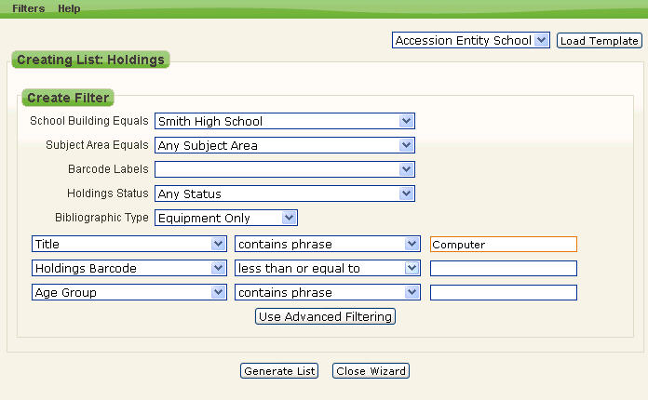
  - You can also click Filter to open the Report Wizard.
  - Specify your criteria using the drop-down lists and fields. For instance, you might select your school, “Equipment Only,” and the title that you want to reclassify.
  - Click Generate List.
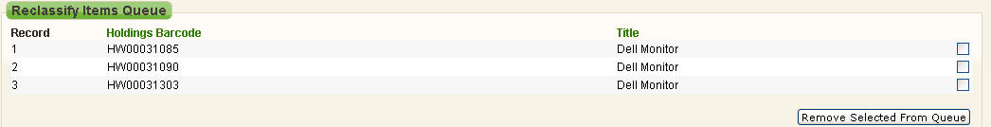
  - The items that you want to reclassify display in the Reclassify Items Queue.
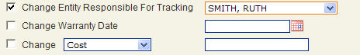
  - Click the check box next to the category you need to reclassify.
  - Select your data from the drop down list or the date from the calendar icon.
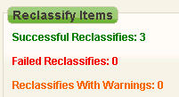
  - Click Reclassify Items.
  - A Successful Reclassifies message with the number of items reclassified will appear when the changes have been made.

Last Checked Out To Report – Accession List

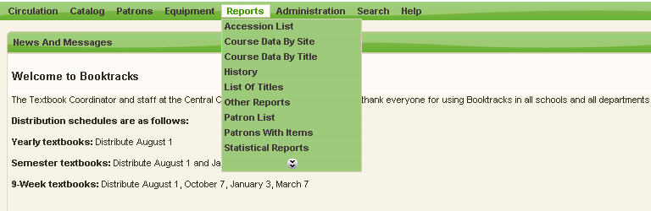
  - Click Reports\Accession List from Booktracks’ Menu Bar.
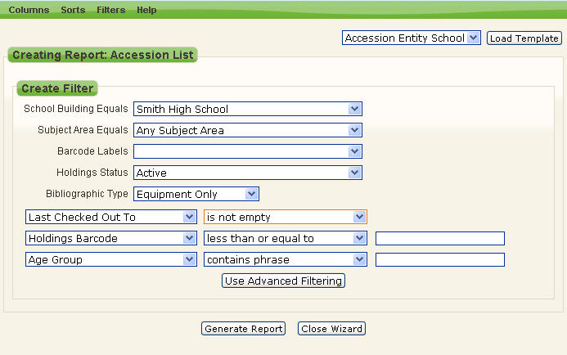
  - Select your school from the School Building Equals drop-down list.
  - Select Equipment Only from the Bibliographic Type drop-down list.
  - Beneath Bibliographic Type, select Last Checked Out To from the first drop-down list and is not empty from the drop-down list to the right.
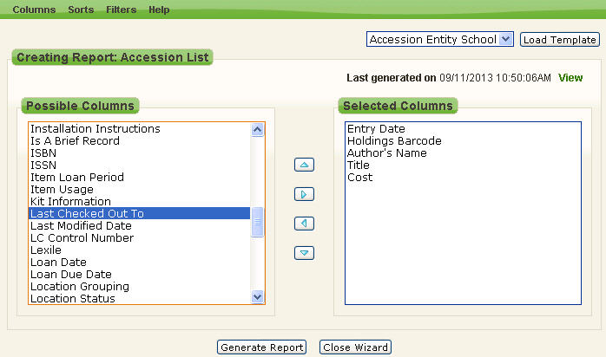
  - Click Columns from the Report Wizard menu bar.
  - Double-click Last Checked Out To which will add it to the Selected Columns form. The Last Checked Out To field shows you one of two types of information: this is either the patron who currently has the item checked out, OR this is the last person to have checked out the item but has checked it in.
  - Double-click Circulation Status under Possible Columns. This shows whether the item is currently “In” or “Out.”
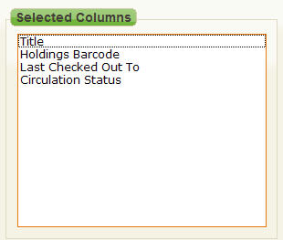
  - Double-click columns under Selected Columns to remove them, and use the arrow buttons to reorder the columns until they display like the picture above.
  - Click Sorts from the Report Wizard menu bar.
  - Double-click Holdings Barcode under Selected Sorts to remove that option.
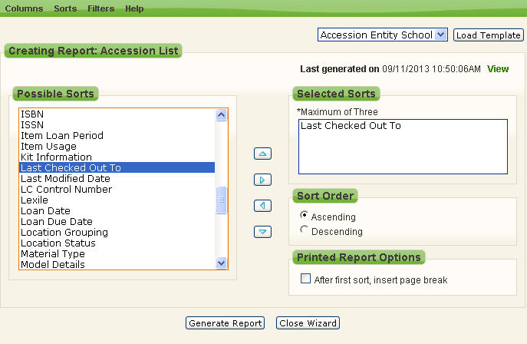
  - Double-click Last Checked Out To for the students’ names to be the sort option.
  - Click Generate Report.
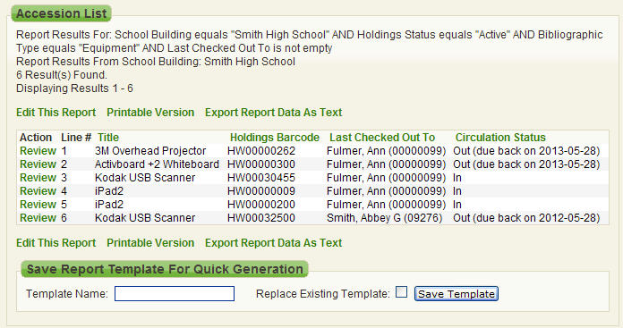
  - This report can be edited, printed or exported.
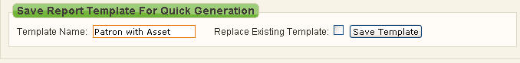
  - At the bottom, you can name the report and click Save Template. The report can be found under Reports\Other Reports; click the reports name.

Equipment Summary

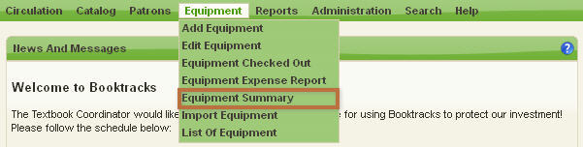

- Click Equipment\Equipment Summary from Booktracks’ Menu Bar.
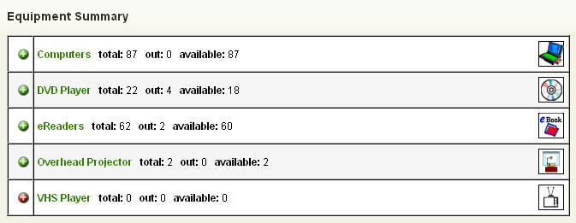
- A list of all the Material Types with asset records displays in a new window. The following values are listed to the right of each type: the total number of holdings records, the number of holdings that are checked out, and the number of holdings that are currently available to be checked out. The color-coding also shows which types have available holdings (green) and which do not (red).
- Click any icon with a plus sign (+) to view a list of individual asset records within that Material Type.

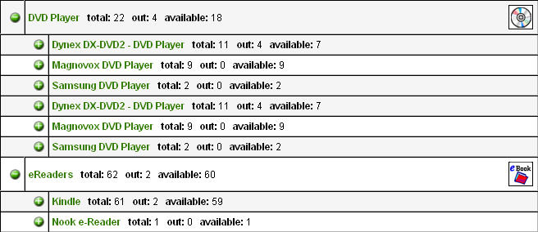

- Click any icon with a plus sign (+) to view the distribution of the assets at each school.

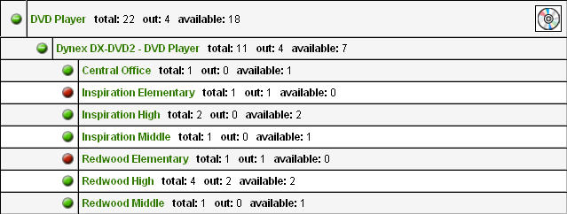

- When you are finished viewing the report, close the window.

Equipment Expense Report

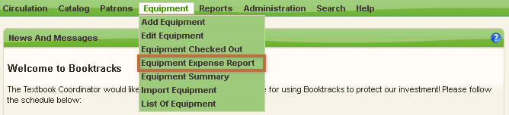
- Click Equipment\Equipment Expense Report from Booktracks’ Menu Bar.
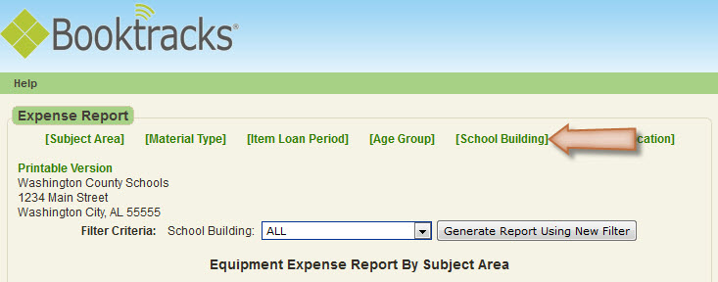
- By default, the report is organized by Subject Area. Click the [links] at the top to organize the data by another category.
